For Immediate Release
July 22, 2019

SENIOR DOGS AT THE LOS ANGELES COUNTY
DEPARTMENT OF ANIMAL CARE AND CONTROL FETCH GRANT

Long Beach – Old dogs have something to wag about this summer, as The Grey Muzzle Organization announces the recipients of its annual grants, and dogs at the Los Angeles County Department of Animal Care and Control (DACC) are among the winners.

DACC is one of 62 animal welfare groups chosen from 240 applicants to receive a grant to help local senior dogs. The groups received a total of nearly $419,000 in grants to help save or improve the lives of at-risk old dogs in communities nationwide.

In the past 11 years, the national nonprofit Grey Muzzle Organization has provided almost $2 million in grants to support its vision of “a world where no old dog dies alone and afraid.”

“Thanks to the generosity of our donors, we’re delighted to help deserving organizations like DACC make a difference in the lives of dogs and people in their communities,” Grey Muzzle’s Executive Director Lisa Lunghofer said. “Many senior dogs in Los Angeles County are enjoying their golden years in loving homes thanks to the wonderful work of DACC.”

The County of Los Angeles Department of Animal Care and Control is one of the largest and most progressive animal control agencies in the United States. Our mission is to the nation in protecting people and animals through compassionate care, community education, proactive intervention, and effective enforcement. (http://animalcare.lacounty.gov/)

The national nonprofit The Grey Muzzle Organization improves the lives of at-risk senior dogs by providing funding and resources to animal shelters, rescue organizations, sanctuaries, and other nonprofit groups nationwide. For details, please visit www.greymuzzle.org
#

Mike, a six-year old Labrador mix, is one of many great senior dogs available for adoption at Los Angeles County Animal Care Centers. Already neutered, Mike is ready to be adopted from the Baldwin Park Animal Care Center today! For more information, please visit https://animalcare.lacounty.gov or call: (626) 962-3577
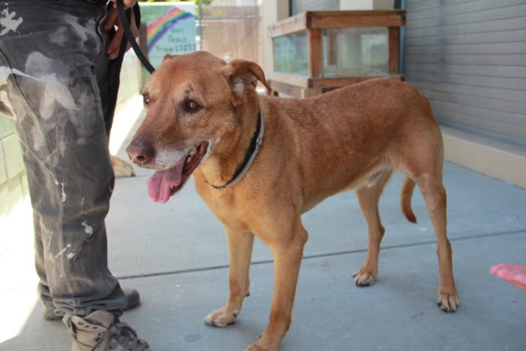
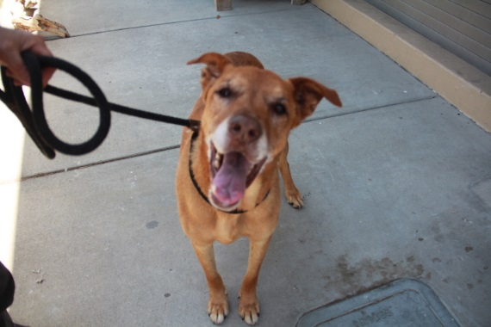

Media Contacts: Don Belton, Los Angeles County Department of Animal Care & Control
Barbara Castleman, The Grey Muzzle Organization - 505-310-3236; Barbara@greymuzzle.org

